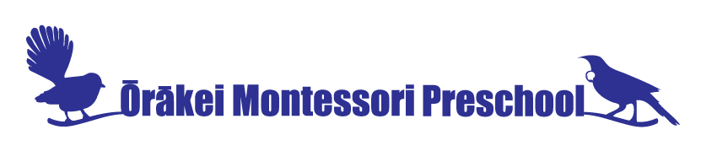
Owner/Manager Pauline Roberts, P.O. Box 28 235, Remuera,
16 Sudeley Street, Orakei, Auckland, N Z
Ph: (09) 529 2518 mob: 027 4707099
Email: pauline@omp.school.nz www.omp.school.nz

REGISTRATION FORM

Child’s Name………………………………………………….……… Child’s Birth Date………………………....

Mother’s Name……………………………………… Father’s Name…………………….……………………….

Mobile Phone……………………………………… Mobile Phone …………..…………………………………

Address ……………….………………………………………………………………………………………………..………….

…………………………………………………………………………………………………………….…………………………..

E-Mail address of main contact:………………………………………………………………………………………..

My child currently attends/has attended………………………………………………….……………………..

Children can begin from 20 months or 2 years of age and continue until 6 years of age.

Preferred commencement date ……/……/……
Preferred mornings/days (minimum of 2 required if under 3 yrs and minimum of 3 required if over). Please circle days and if morning (M) or full day session (F) required.

Monday: (M) or (F) Tuesday: (M) or (F) Wednesday: (M) or (F)
Thursday: (M) or (F) Friday: (M) or (F)

All children will have their name kept on the waiting list and be offered a place when available upon receipt of this completed form and payment of the registration fee.

REGISTRATION FEE: $50 (This is non-refundable fee). Payment by Bank deposit to: account# 02-0256-0079576-000

Please return this completed form to Pauline Roberts, you can scan and email back to pauline@omp.school.nz

